Topic: Medical Needs – The Role of the Specialist Teacher
Date: Wednesday 20th April 2022
Venue: Google Meeting
Time: 10:00-11:30am
Speaker: Hackney SENDIAGS & Medical Needs Specialist Teacher

The Workshop will focus on:
- Medical Needs Statutory Guidance - what does the legislation say?
- The role of the SENCO and Parents in meeting the needs of children with medical needs
- The role of the specialist teacher in supporting children, parents and the school
- What is a care plan?
- What is a well-being plan?
If you have a child with medical needs this session is for you!!

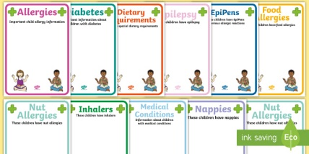

Register your attendance by, Monday 18th April 2022
Contact SENDIAGS on 07500 066 513 or SENDIAGS@hackney.gov.uk

